Project Documentation Phase
FSD Documentation

Date | 30 September 2026
Team ID | 6abab772b81abcc53b06d3f7
Project Name | Import Data using Transform Maps (Spreadsheet)
Maximum Marks | 5 Marks

1. Introduction
- Project Title: Import Data using Transform Maps (Spreadsheet)
- Team Members & Roles:
  - Arish Mohamed: Scrum Master & Backend / Integration Lead
  - Karuppasamy: UI/UX & Frontend Developer
  - Thangaselavn: Database Administrator & Mapping Engine Developer
  - Jayaprakash: Quality Assurance & Testing Lead

2. Project Overview
- Purpose: The primary purpose of this project is to provide a robust, automated web-based solution for importing structured data from spreadsheet files (.csv, .xlsx) into a target database. By utilizing configurable "Transform Maps," users can seamlessly map source columns to target schema fields, apply data transformation rules, handle unique identifiers (coalesce keys), and track import metrics via an intuitive dashboard.
- Features:
  - Secure user authentication and workspace management.
  - Multi-format spreadsheet file upload and live preview (.csv, .xlsx).
  - Dynamic Transform Map configuration interface linking source columns to target database fields.
  - Field transformation rules (e.g., date formatting, concatenation, default values).
  - Batch data import execution with insert/update handling based on coalesce keys.
  - Comprehensive error logging and validation reports for failed row imports.
  - Real-time dashboard summary metrics (total, imported, skipped, and error counts).

3. Architecture
- Frontend: Built using React.js, providing a responsive and component-driven Single Page Application (SPA). It utilizes React Router for navigation, Axios for API communication, and modern UI components for state management during file uploads and map configurations.
- Backend: Developed using Node.js and Express.js to handle RESTful API endpoints, business logic, file parsing streams, and the core transform mapping engine.
- Database: Powered by MongoDB (using Mongoose ODM). The database schema stores user profiles, transform map configurations, imported dataset records, and execution error logs as structured collections (e.g., Users, TransformMaps, ImportLogs, TargetRecords).

4. Setup Instructions
- Prerequisites:
  - Node.js (v16.x or higher) installed locally.
  - MongoDB installed locally or a cloud cluster connection URI (MongoDB Atlas).
  - npm (Node Package Manager).
- Installation:
  - Clone the repository:
git clone https://github.com/your-repo/import-data-transform-maps.git

cd import-data-transform-maps
Set up the Backend (Server):

cd server
npm instal
l
Create a .env file in the server directory and configure your environment variables:

PORT=5000
MONGO_URI=mongodb://localhost:27017/transform_maps_db
JWT_SECRET=your_jwt_secret_key
Set up the Frontend (Client): cd ../client
npm install

5. Folder Structure
- Client (React Frontend):
client/
├── public/
├── src/
│ ├── components/ # Reusable UI elements (Navbar, Modals, Tables)
│ ├── pages/ # View pages (Login, Dashboard, Upload, TransformMap, Reports)
│ ├── services/ # Axios API service integrations
│ ├── App.js
│ └── index.js
└── package.json
Server (Node.js Backend): server/
├── config/ # Database connection setup
├── controllers/ # Business logic for auth, file parsing, and mapping
├── models/ # Mongoose schemas (User, TransformMap, Log)
├── routes/ # Express API route handlers
├── middleware/ # Authentication & file upload middleware (Multer)
├── server.js # Entry point
└── package.json

6. Running the Application

Backend Server:
cd server
npm start

Frontend Server:

cd client
npm start

7. API Documentation

Endpoint | Method | Parameters / Body | Description | Example Response
/api/auth/login | POST | email, password | Authenticates user and returns JWT token. | {"token": "eyJhbGciOi...", "status": "success"}
/api/files/upload | POST | multipart/form-data (file) | Uploads and parses CSV/XLSX file headers. | {"fileId": "64a...", "columns": ["name", "email", "date"]}
/api/transforms | POST | mapName, fieldMappings, coalesceKey | Creates and saves a new Transform Map configuration. | {"mapId": "3b2...", "message": "Transform Map saved successfully"}
/api/import/execute | POST | fileId, mapId | Executes batch import process using the map. | {"total": 500, "imported": 490, "errors": 10}

8. Authentication
- Authentication and authorization are handled using JSON Web Tokens (JWT) combined with secure password hashing via Bcrypt.
- Upon successful login (/api/auth/login), the server issues a signed JWT token containing the user's ID and role.
- The frontend stores this token in local storage and attaches it as a Bearer Token in the HTTP Authorization header for all protected API routes, ensuring secure session management.

9. User Interface
- Dashboard View: Displays summary metrics cards (Total Imports, Success Rate, Failed Rows) and a table of recent import history.
- File Upload & Preview View: Features a drag-and-drop zone for .csv and .xlsx files with an instant tabular preview of the first 5 raw data rows.
- Transform Map Builder: An interactive drag-and-drop or dropdown-based interface allowing users to map source spreadsheet headers directly to target database schema attributes, complete with rule toggles and coalesce key selection.

10. Testing
- Testing Strategy: A multi-layered testing approach was implemented covering unit testing, integration testing, performance benchmarking, and User Acceptance Testing (UAT).
- Tools Used:
  - Jest & Supertest: For backend API unit and integration testing.
  - Locust / Apache JMeter: For load testing spreadsheet uploads up to 20,000 rows.
  - Manual UAT: Conducted by the testing lead and team members to validate end-to-end workflows and error logging accuracy.

11. Screenshots or Demo
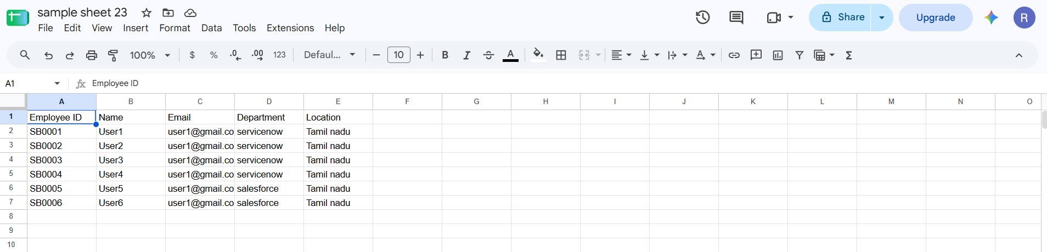

12. Known Issues
- Large File Memory Spikes: Parsing extremely large .xlsx files (>25MB) directly into DOM memory can cause brief performance throttling. This is mitigated by recommending CSV formats or setting a strict 20MB file upload limit.
- Date Serial Formatting: Occasional formatting discrepancies between Microsoft Excel serial date numbers and standard ISO string formats require explicit rule mapping before execution.

13. Future Enhancements
- Asynchronous Task Queues: Integrate Celery / BullMQ with Redis to handle background processing for massive datasets (>50,000 rows) without blocking the UI thread.
- Extended File Formats: Add native support for JSON and XML data source imports.
- Scheduled Imports: Implement cron-based automated periodic imports from cloud storage buckets (e.g., AWS S3 or Google Drive).

